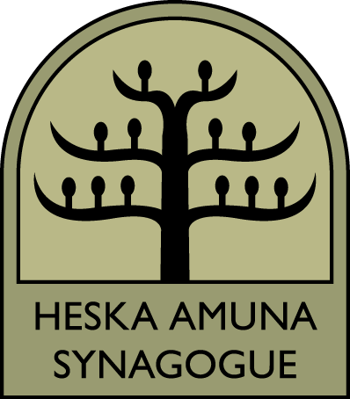
Pre – K & Kindergarten

Teacher: Brooke Browarnik
Textbooks:
●Teach Me Torah
●Let’s Discover the Alef-Bet
●Jewish and Me: Fall and Spring Holidays
●Jewish and Me: Mitzvot
●Let’s Discover the Synagogue
Objective for Hebrew Goals:
•The students will be introduced to the Alef Bet
●The student will be able to identify Hebrew letters
●The students will be able to memorize the Shabbat blessings
Prayer Goals:
●The students will be able to recite the Shabbat Blessings
Objective for Holidays: Students will celebrate:
●Rosh Hashanah
●Yom Kippur
●Sukkot
●Simchat Torah
●Chanukah
●Tu B’Shevat
●Purim
●Passover
●Shavuot
Parents along with their children will be able to engage in activities in the home that will re-enforce what is learned in class. Materials will be sent home to the parent so they can partner with the teacher
Goals:
●The students will be able to discover the excitement of the holidays
●The students will be able learn various movements i.e.: spinning like a dreidel, make the sounds of a shofar
●The students and their families will be involved in home activities that will further enhance understanding of customs, blessings, etc
Objectives for Bible:
●The students will be introduced to Biblical figures such as Adam and Eve, Noah, Jacob and Esau in Set 1. In set 2 the children will be introduced to Moses, Miriam, Jonah
Goals:
●The students will be able to familiarize themselves with our ancestors
●The students will be able to understand the value associated with each Bible story
Objective for Mitzvot:
The students will be introduced to the concept of Mitzvot and how to do a Mitzvah

Goals:
• The students will be able to understand the different concept of each Mitzvot
• The student will be able to learn to perform Mitzvot such as those listed below and weave these ideas into the Torah
1. Doing Mitzvot
2. Helping others feel better
3. Taking care of myself
4. Shalom Bayit
5. Being Kind
6. Caring for animals
7. Giving Tzedakah
8. Protecting animals
• The students will be able to make decisions based on Jewish values
• List and explain the primary Jewish values to follow in life
• Exhibit Jewish values in daily life
• Celebrate life-cycle events according to Jewish tradition
• Explain the background and value of Jewish life-cycle events
• Define “Mitzvot” and the holy obligations to observe them
• Explain the ideological differences between Conservative and other branches of Judaism

Family Education Programs:

•Family Minyan
•Sukkot Family Education Program
•Passover Seder

Second Grade and Third Grade

Teacher: Jordan Shipowitz

Textbooks:

●Shalom Alef Bet

●Great Israel Scavenger Hunt

●The Jewish Holiday Treasure Trail

●Let’s Discover the Bible

Hebrew Objectives:

•The student will be introduced to decoding skills using simple Hebrew words

•The students will be able to understand the concept of reading right to left

•The students will be able to recognize their Hebrew names

Prayer Goals:

•The student will be introduced to Shema, Mah Tovu, Baruchu and

Mi Chomocha

•The students will be able to recite the Shabbat blessings, Shema and snack blessings by rote
Goals:
•The students will be able to identify Hebrew letters, including look-a-like letters, and decode simple Hebrew words

•The student will be able to recognize Hebrew vowels
•The students will be able to recite the Shabbat Brachot
•The students will be able to recite the Shema

Judaic Objectives:

•The students will be introduced to Judaic symbols and be able to recognize them

Jewish Symbols i.e.: Candlesticks
•Candlesticks
•Kiddish cup
•Megillah
•Torah
•Lulav & Etrog
•Jewish Star
•Dreidel
•Shofar
•Seder Plate
•Spice Box
•Havdalah candle

Holiday Celebrations Objective:

•Using their own experiences, the children will understand rituals symbols, traditions and stories connected to each holiday

Goals:

•The student will be able to connect home rituals with Synagogue celebrations

•The student will be able to recognize holiday symbols

•The families will be ebcouraged to learn how to celebrate holidays with appropriate materials sent home

•The student will be able to learn key vocabulary for each holiday

•The student will be able to learn appropriate blessings for each holiday

Israel Objective:

•The students will be introduced to Israel’s major cities as well as key cultural sites

Goals:

•The student will be able to understand the ties between modern Israel and Biblical Israel

•The student will be able to learn key conversational Hebrew vocabulary

Bible Objective:

•The student will be introduced to key biblical figures beginning with Creation and concluding with Jonah

Goals:

•The student will be able to recognize key figures

•The students will be able to understand the different roles that our matriarchs and patriarchs played in our history
• Explore basic concepts about God including how we talk to God, how we act in God’s image, our covenant, Mitzvot and what it means that God is one.

Family Education Programs:

•Family Minyan
•Sukkot Family Education Program
•Passover Seder
•Siddur Book Sox Decorating Program
•Siddur Presentation

