BLESSINGS FOR LIGHTING YOUR HANUKKAH CANDLES
FUN FACTS:
- What is a Menorah called in Hebrew? A Hanukkiah!
- When do we light candles? Right after nightfall on each night of Hanukkah.
- Why do we light candles? (1) To show that we remember the miracle of Hanukkah. (2) To celebrate our strong determination to keep the light of our heritage burning bright.
- What do you call the candle you use to light the other candles? The Shamash!
- Where do you put your Menorah? Put it in a window if you can; this is to show the outside world that we are celebrating the miracle of Hanukkah. (But don’t do this if you don’t have a perfect place for your candles to be safe while they are burning.)
- How do we light our candles?
  - Add one candle for each new night.
  - Place the candles for each day from right to left (the same way as we read Hebrew!)
  - Light the Shamash first (it is usually the higher candle in your Menorah).
  - Chant our Hanukkah prayers.
  - Light the candles by lighting the candle for the newest day first. (So you will always be lighting the candle that represents your first day of Hanukkah last.)
  - Candles should burn for at least 30 minutes.
  - Do not blow out your candles after you light them; they should burn out on their own.
  - Enjoy!!!

The Blessings
The first blessing is the BLESSING OVER THE CANDLES:
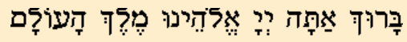
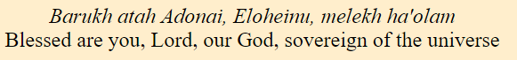
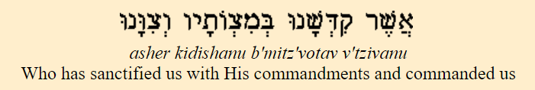
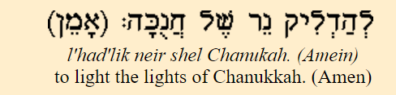
The second blessing is the BLESSING FOR HAVING RECEIVED THE HANUKKAH MIRACLE:
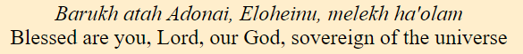
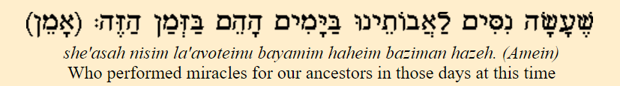
And (only on the first day) a third blessing is chanted to say we are thankful for being alive this day to celebrate Hanukkah – THE SHEHECHEYANU:
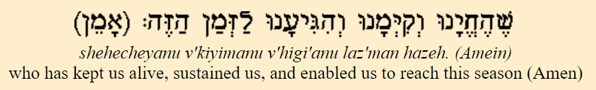

MAOZ TZUR (ROCK OF AGES)
Rock of Ages let our song,
Praise thy saving power;
Thou amidst the raging foes,
Wast our sheltering tower.
Furiously they assailed us,
But Thine arm availed us
And Thy word broke their sword,
When our own strength failed us.
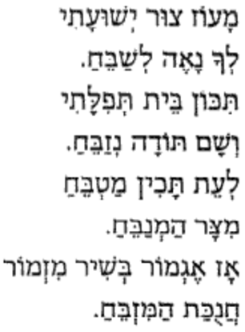
Maoz tzur y’shuati
l’cha naeh l’shabeach
Tikon beit t’filati
v’sham todah n’zabeach.
L’eit tachin matbeach
mitzar hamnabeach
Az egmor b’shir mizmor
chanukat hamizbeach
Az egmor b’shir mizmor
chanukat hamizbeach.

